SIMATS ENGINEERING (SAVEETHA SCHOOL OF ENGINEERING)
Department of Computer Science and Engineering

ASSESSMENT TOOL 3 – CASE STUDY

Course Code: | CSA06 | Course Title: | Design and Analysis of Algorithms
CO Assessed: | CO3: Articulation (BL4, BL5) | Assessment: | Assessment Tool 2 – Case Study
Weightage: | 20% of CIA | Total Marks: | 100 (2 Questions × 50 Marks)
CO3 Statement: | Design Divide and Conquer algorithms for Merge Sort, Quick Sort, Binary Search and Matrix Multiplication
Student Name: | CH AKHIL | Reg. No.: | 192525250
Section / Batch: | 2025 | Date: | 19-08-2026

Instructions to Students
- Answer both questions. Each question carries 50 Marks. Total: 100 Marks.
- Carefully analyze the given case study questions.
- Explain in detail with sample code if needed.
- Clearly identifies all key issues, in-depth analysis, Innovative, feasible solutions with strong justification

Question Type | Description | Questions | Total Marks
Case Study | Focus on Design Divide and Conquer algorithms: Merge Sort, Quick Sort,  Binary Search and Matrix  Multiplication | Q1 – Q2 | 100

SECTION A – CASE STUDY

1.
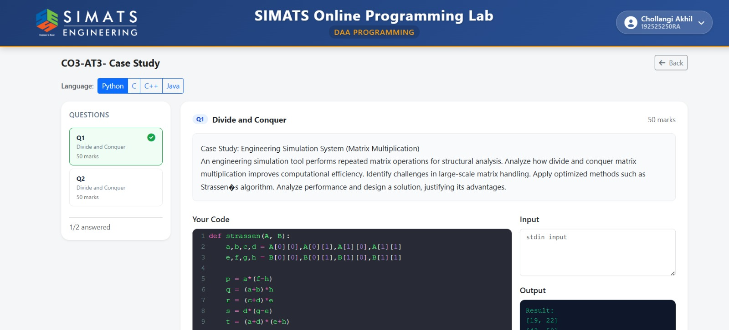

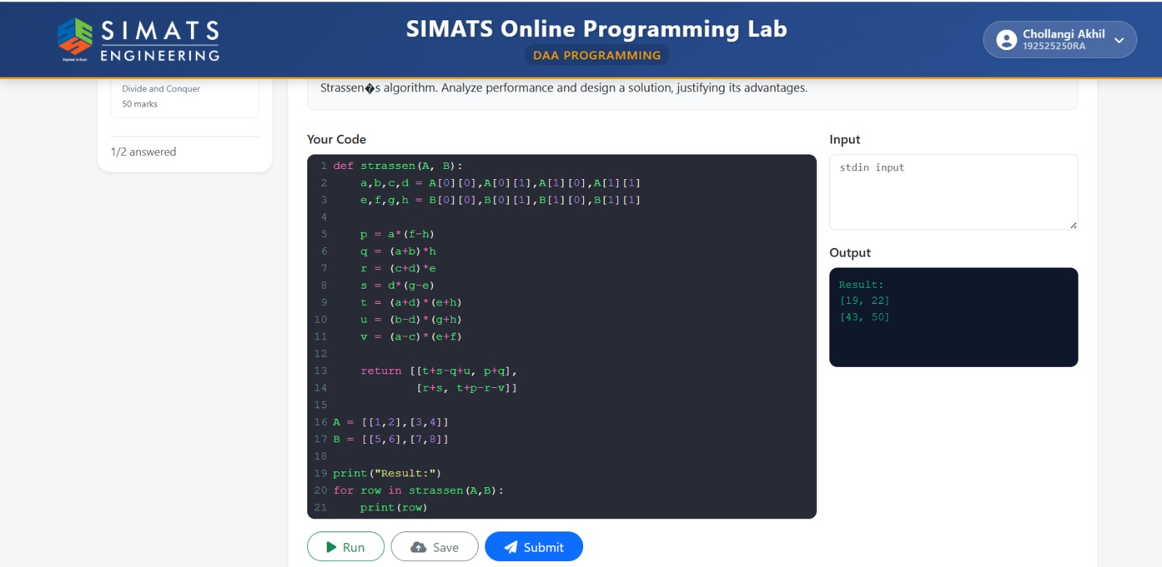

2.
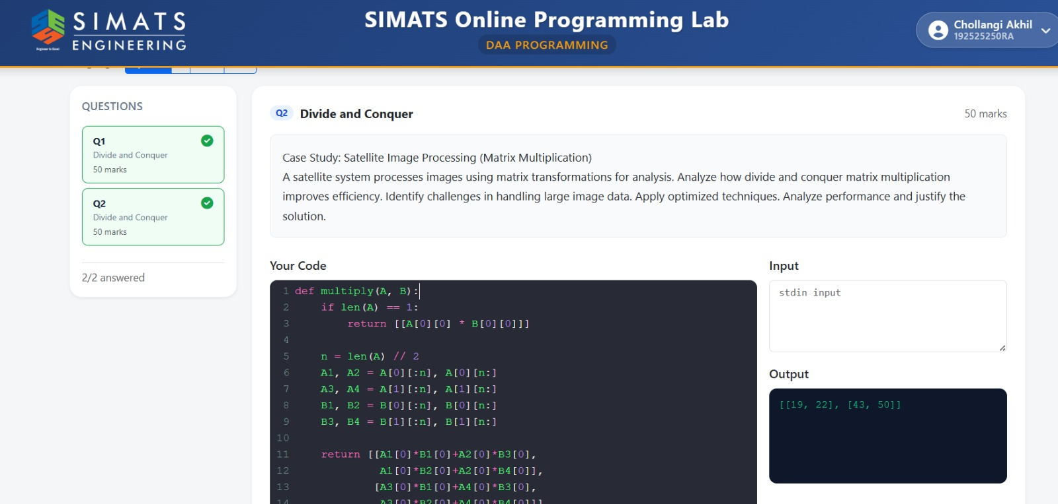

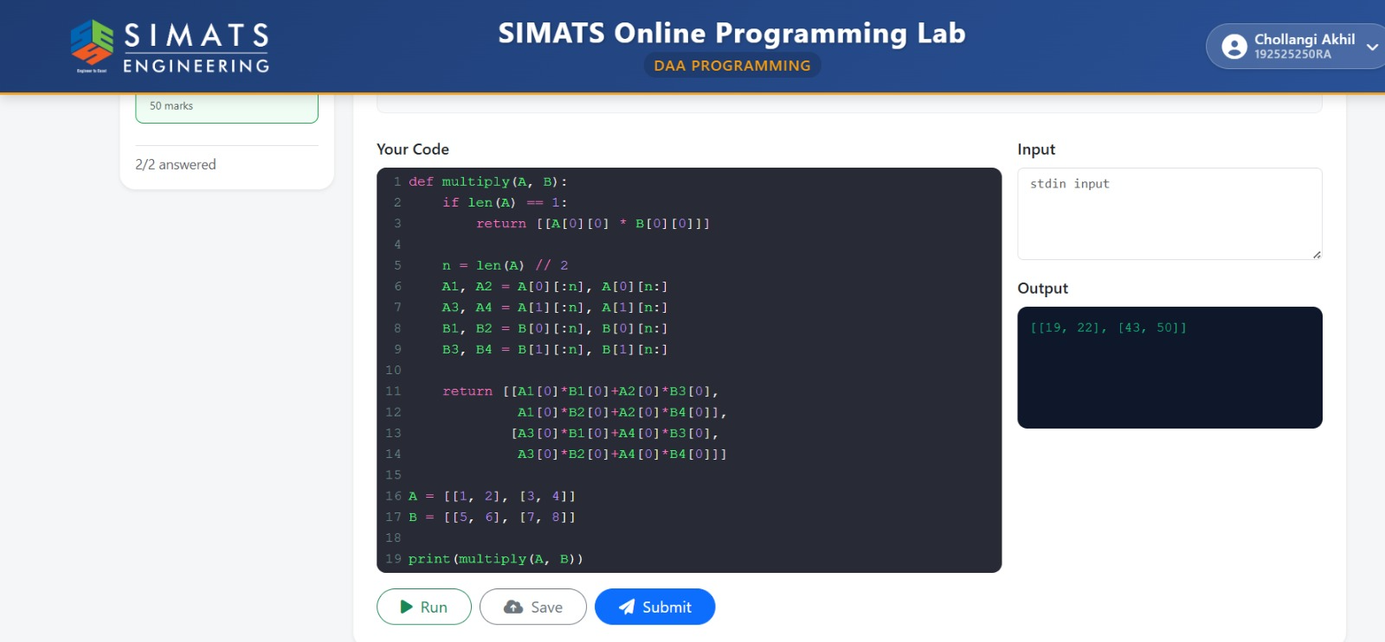

Code of Conduct
I CH AKHIL(192525250) (Name / Reg No) certify that this submission is my original work and that I have adhered to the guidelines specified for this assessment. I understand that any violation of academic integrity rules will result in disciplinary action.
Signature of the Student: CH AKHIL

RUBRICS FOR CALCULATION

 |  | Case Study
Criteria | Weightage | Level 4 –  Exemplary | Level 3 –  Proficient | Level 2 –  Developing | Level 1 –  Beginning
Understanding of Case | 25 | Thorough understanding; clearly  identifies all key issues | Good understanding with most issues identified | Basic understanding;  some issues missed | Poor understanding;  problem not  identified correctly
Application of Concepts | 25 | Effectively applies relevant concepts to  analyze the case deeply | Applies appropriate  concepts with minor gaps | Limited application of concepts | Fails to apply relevant concepts
Analysis | 20 | In-depth analysis with strong  reasoning and insights | Good analysis with logical reasoning | Basic analysis with limited depth | Weak or no analysis; lacks reasoning
Solution Design | 20 | Innovative, feasible  solutions with strong justification | Logical solutions with adequate justification | Basic solutions with weak  justification | Incorrect or no solution provided
Clarity | 10 | Clear, well-structured, and easy to understand | Organized and understandable presentation | Limited clarity and structure | Poor clarity; difficult to understand
Mark Evaluation:

Case Study | Understanding  of case  (25) | Applications of concepts  (25) | Analysis  (20) | Solution  Design  (20) | Clarity  (10) | Total  Marks  (Each -  50)
Q1
Q2
 |  |  |  | Overall Total (100)

Faculty In-charge | Course Coordinator | Head of Department
Name: __________________  Signature: _______________ | Signature: _______________ | Signature: _______________
Date: ___________________ | Date: ___________________ | Date: ___________________

